**Team:** Team A (The A-team)

**Architecture Design:**

For the design of our web application, we decided to use a Model-View-Controller architecture.

We decided on this type of architecture because it provides a natural separation between the layers while still requiring these layers to communicate with one-another to update their states. This architecture also gives us more room to be flexible in the development and design of the application, with different parts being developed in their own way. On top of this, the design will also cater to the user as it provides enough separation to help users who may be using the app for different reasons, for a different desired outcome.

**Architecture Design Diagram:** <https://docs.google.com/drawings/d/1pDlYtZC9G7hPxKOlmodTJcjZb9GsB2UIYchWCnJmJe4/edit> - direct link for edit purposes

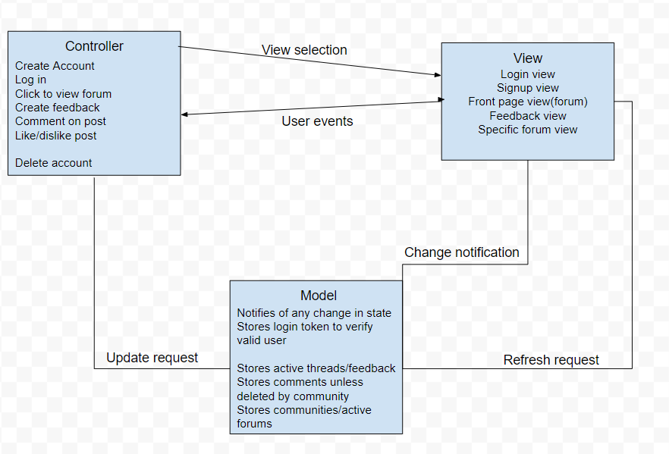

**Design Description:**

The architecture of our app is designed from several different perspectives and parts which aim to provide the different types of users a similar, mutually beneficial experience.

The view for the app handles all of the UI and actual physical design. This will be mostly handled through React. The application will have lots of different views that can be displayed by navigating through the page. The login view will be the first one, leading the user to the primary page with the open listed feedback. After this page, almost any interaction will lead the user to a primary controller which will handle the inputs given by the user.

The controller will handle several of the events which can be found from the view. These events will include the submission of feedback which will be provided by buttons directing the user. Providing a way to view forums, create feedback, view more pages, comment on feedback, and liking/disliking posts made by other users. Upon a given input, the system will send a signal to the view controller to see if any state changes need to be made.

The model for our app handles the data. The view has the ability to access and alter any of the data for different described elements in the app. Any of the changes made to the state will be stored and might provide the user with some sort of verification that they’ve changed the state of the app. This update may also be sent to the view and controller part of the architecture. This layer of the architecture is in charge of communicating with the other components and using this check to update the other layers.